1. 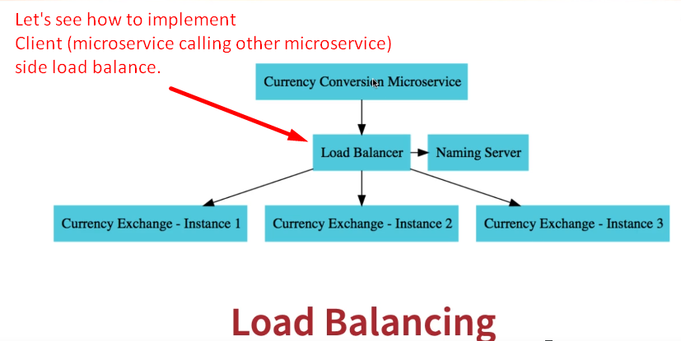
2. 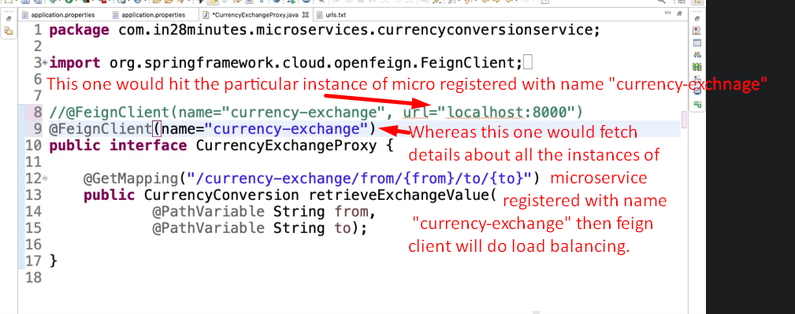
3. Let’s lunch microservice Currency Exchange on two ports 8000, 8001.
4. 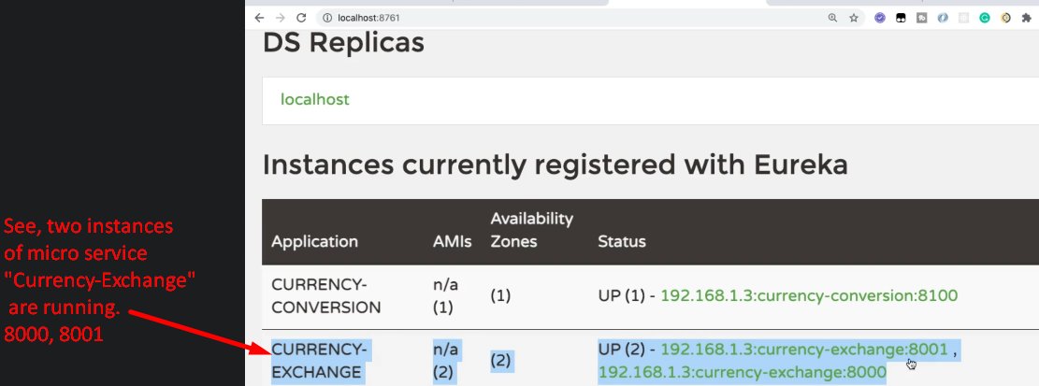
5. 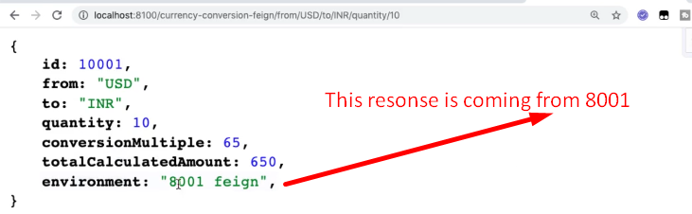  
   Again hit the same above URL.  
   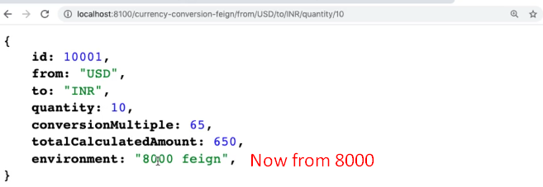  
   If always coming from 8000, give it a little bit time about 30-40seconds to do load balancing.
6. 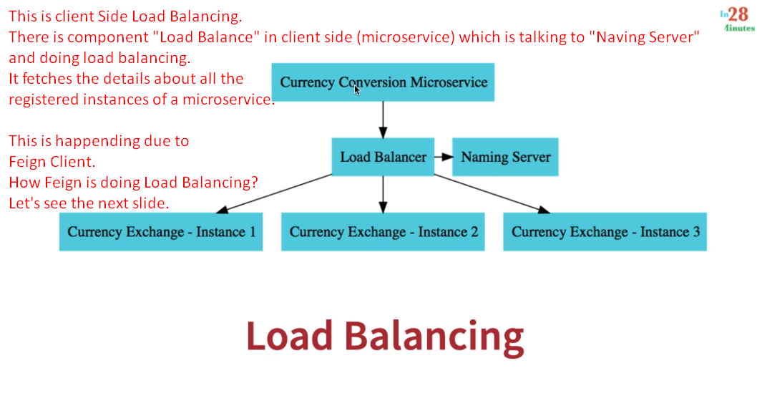
7. Let’s see how Feign does load balancing?
   1. 